Information Security Lab 7
(kali㉿Kali)-[~]
└─$ cd /home

┌──(kali㉿Kali)-[/home]
└─$ ls
file.txt kali

┌──(kali㉿Kali)-[/home]
└─$

┌──(kali㉿Kali)-[/home]
└─$ nano write_line.sh

┌──(kali㉿Kali)-[/home]
└─$ ls
file.txt kali

┌──(kali㉿Kali)-[/home]
└─$ sudo nano write_line.sh
[sudo] password for kali:

┌──(kali㉿Kali)-[/home]
└─$ ls
file.txt kali write_line.sh

┌──(kali㉿Kali)-[/home]
└─$ chmod +x /home/write_line.sh
chmod: changing permissions of '/home/write_line.sh': Operation not permitted

┌──(kali㉿Kali)-[/home]
└─$ sudo chmod +x /home/write_line.sh

┌──(kali㉿Kali)-[/home]
└─$ crontab e
e: No such file or directory

┌──(kali㉿Kali)-[/home]
└─$ crontab -e
no crontab for kali - using an empty one
Select an editor. To change later, run select-editor again.
1. /bin/nano <---- easiest
2. /usr/bin/vim.basic
3. /usr/bin/vim.tiny

Choose 1-3 [1]: 1
crontab: installing new crontab

┌──(kali㉿Kali)-[/home]
└─$ cat /home/file.txt

┌──(kali㉿Kali)-[/home]
└─$ cat /home/file.txt

┌──(kali㉿Kali)-[/home]
└─$ crontab -l
# Edit this file to introduce tasks to be run by cron.
#
# Each task to run has to be defined through a single line
# indicating with different fields when the task will be run
# and what command to run for the task
#
# To define the time you can provide concrete values for
# minute (m), hour (h), day of month (dom), month (mon),
# and day of week (dow) or use '*' in these fields (for 'any').
#
# Notice that tasks will be started based on the cron's system
# daemon's notion of time and timezones.
#
# Output of the crontab jobs (including errors) is sent through
# email to the user the crontab file belongs to (unless redirected).
#
# For example, you can run a backup of all your user accounts
# at 5 a.m every week with:
# 0 5 * * 1 tar -zcf /var/backups/home.tgz /home/
#
# For more information see the manual pages of crontab(5) and cron(8)
#
# m h dom mon dow command
* * * * * /home/write_line.sh

┌──(kali㉿Kali)-[/home]
└─$ cat /home/write_line.sh
#!/bin/bash
echo "New line at $(date)" >> /home/file.txt

┌──(kali㉿Kali)-[/home]
└─$ ls -l /home/write_line.sh /home/file.txt
-rw-r--r-- 1 root root 0 Oct 1 03:23 /home/file.txt
-rwxr-xr-x 1 root root 57 Oct 1 03:35 /home/write_line.sh

┌──(kali㉿Kali)-[/home]
└─$ cat /home/write_line.sh
#!/bin/bash
echo "New line at $(date)" >> /home/file.txt

┌──(kali㉿Kali)-[/home]
└─$ cat file.txt

┌──(kali㉿Kali)-[/home]
└─$ sudo rm /home/write_line.sh /home/file.txt

┌──(kali㉿Kali)-[/home]
└─$ nano ~/write_line.sh

┌──(kali㉿Kali)-[/home]
└─$ chmod +x ~/write_line.sh

┌──(kali㉿Kali)-[/home]
└─$ touch ~/file.txt

┌──(kali㉿Kali)-[/home]
└─$ crontab -e
crontab: installing new crontab

┌──(kali㉿Kali)-[/home]
└─$ cat ~/file.txt
New line at Thu Oct 1 03:49:01 AM EDT 2026

┌──(kali㉿Kali)-[/home]
└─$ cat ~/file.txt
New line at Thu Oct 1 03:49:01 AM EDT 2026

┌──(kali㉿Kali)-[/home]
└─$ cat ~/file.txt
New line at Thu Oct 1 03:49:01 AM EDT 2026
New line at Thu Oct 1 03:50:01 AM EDT 2026

┌──(kali㉿Kali)-[/home]
└─$ crontab -r

┌──(kali㉿Kali)-[/home]
└─$ crontab -l
no crontab for kali

┌──(kali㉿Kali)-[/home]
└─$

Telegram Bot
(kali㉿Kali)-[~]
└─$ mkdir telegram_bot

┌──(kali㉿Kali)-[~]
└─$ cd telegram_bot

┌──(kali㉿Kali)-[~/telegram_bot]
└─$ nano bot.sh

┌──(kali㉿Kali)-[~/telegram_bot]
└─$ chmod +x bot.sh

┌──(kali㉿Kali)-[~/telegram_bot]
└─$ ./bot.sh
{"ok":true,"result":{"message_id":2,"from":{"id":8942649104,"is_bot":true,"first_name":"Mr Robot","username":"Virgon3000_bot"},"chat":{"id":1741721843,"first_name":"Nuriki","username":"Nurgazy587","type":"private"},"date":1791229324,"text":"\ud83d\udd14 \u0421\u0435\u0440\u0432\u0435\u0440 \u0440\u0430\u0431\u043e\u0442\u0430\u0435\u0442! \u0412\u0440\u0435\u043c\u044f: Mon Oct 5 03:42:00 PM EDT 2026"}}
┌──(kali㉿Kali)-[~/telegram_bot]
└─$ pwd
/home/kali/telegram_bot

┌──(kali㉿Kali)-[~/telegram_bot]
└─$ crontab -e
no crontab for kali - using an empty one
No modification made

┌──(kali㉿Kali)-[~/telegram_bot]
└─$ crontab -e
no crontab for kali - using an empty one
crontab: installing new crontab

┌──(kali㉿Kali)-[~/telegram_bot]
└─$ crontab -l
# Edit this file to introduce tasks to be run by cron.
#
# Each task to run has to be defined through a single line
# indicating with different fields when the task will be run
# and what command to run for the task
#
# To define the time you can provide concrete values for
# minute (m), hour (h), day of month (dom), month (mon),
# and day of week (dow) or use '*' in these fields (for 'any').
#
# Notice that tasks will be started based on the cron's system
# daemon's notion of time and timezones.
#
# Output of the crontab jobs (including errors) is sent through
# email to the user the crontab file belongs to (unless redirected).
#
# For example, you can run a backup of all your user accounts
# at 5 a.m every week with:
# 0 5 * * 1 tar -zcf /var/backups/home.tgz /home/
#
# For more information see the manual pages of crontab(5) and cron(8)
#
# m h dom mon dow command
*/1 * * * * /home/kali/telegram_bot/alert.sh

┌──(kali㉿Kali)-[~/telegram_bot]
└─$ crontab -e
No modification made

┌──(kali㉿Kali)-[~/telegram_bot]
└─$ crontab -r

┌──(kali㉿Kali)-[~/telegram_bot]
└─$ crontab -e
no crontab for kali - using an empty one
crontab: installing new crontab

┌──(kali㉿Kali)-[~/telegram_bot]
└─$ crontab -l
# Edit this file to introduce tasks to be run by cron.
#
# Each task to run has to be defined through a single line
# indicating with different fields when the task will be run
# and what command to run for the task
#
# To define the time you can provide concrete values for
# minute (m), hour (h), day of month (dom), month (mon),
# and day of week (dow) or use '*' in these fields (for 'any').
#
# Notice that tasks will be started based on the cron's system
# daemon's notion of time and timezones.
#
# Output of the crontab jobs (including errors) is sent through
# email to the user the crontab file belongs to (unless redirected).
#
# For example, you can run a backup of all your user accounts
# at 5 a.m every week with:
# 0 5 * * 1 tar -zcf /var/backups/home.tgz /home/
#
# For more information see the manual pages of crontab(5) and cron(8)
#
# m h dom mon dow command
*/1 * * * * /home/kali/telegram_bot/bot.sh

┌──(kali㉿Kali)-[~/telegram_bot]
└─$

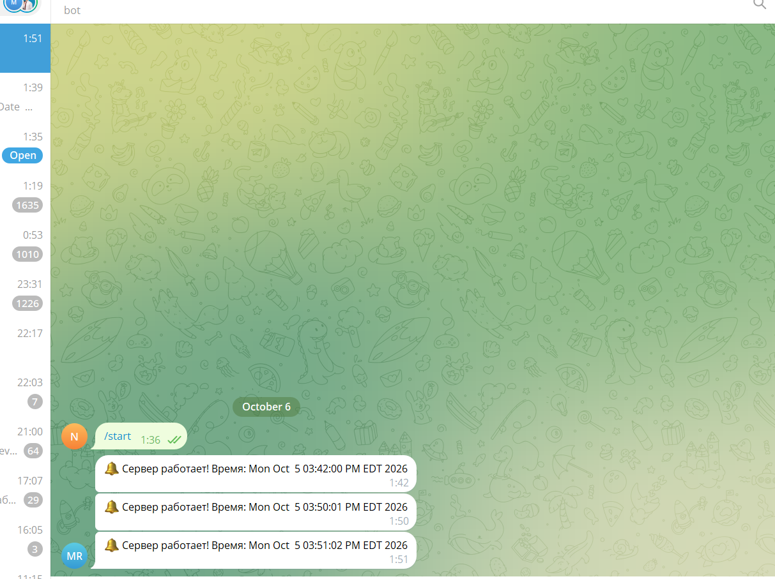
( GNU nano 8.7.1 bot.sh
#!/bin/bash
TOKEN="I cannot show "
CHAT_ID="I cannot show"

curl -s -X POST "https://api.telegram.org/bot${TOKEN}/sendMessage" \
-d chat_id="${CHAT_ID}" \
-d text="🔔 Сервер работает! Время: $(date)"

)

